**Lab 1**

**Theory**

HTML (Hypertext Markup Language) is the backbone of web development, providing the structure and foundation for creating web pages. HTML consists of a variety of tags, which are like building blocks that define different elements and content within a webpage. These tags are enclosed within angle brackets and come in pairs, typically an opening tag and a closing tag. For instance, the <p> tag is used for paragraphs, <h1> to <h6> tags for headings, <a> for links, and <img> for images. HTML tags serve to structure content, format text, embed multimedia, create links, and define the layout of a webpage. By using the right combination of HTML tags, web developers can craft visually appealing and interactive websites, making it an essential language for anyone working in web development.

**Task 1:**

**Create a simple page to demonstrate the usage of necessary html tags. The page should contain image and their description.**

**Code**

<!DOCTYPE html>

<html lang="en">

<head>

<meta charset="UTF-8">

<meta name="viewport" content="width=device-width, initial-scale=1.0" >

<title>Document</title>

</head>

<body>

<table>

<th>

<div style="border: 10PX; background-color: rgb(226, 233, 233);">

<img src="../Images/Html_Image.png" alt="Html_Image" style="width: 400px; height:250px; padding-top: 10px;">

<p style="text-align: justify; font-weight: 100; padding: 0 20PX;">

HTML (Hypertext Markup Language) is a markup language used for structuring and creating the content of web pages. It provides a set of tags and elements that define the structure of a webpage, including headings, paragraphs, links, images, and more. HTML is essential for organizing and presenting information on the internet.

</p>

</div>

</th>

<td>

<th>

<div style="border: 10PX; background-color:#ede4e4 ;">

<img src="../Images/Css_image.png" alt="Css_image" style="width: 400px; height:250px; padding-top: 10px;">

<p style="text-align: justify; font-weight: 100;padding: 0 20px;">

CSS (Cascading Style Sheets) is a stylesheet language used to control the visual presentation and layout of web pages written in HTML. It allows web developers to define the colors, fonts, spacing, and positioning of elements on a webpage. CSS plays a crucial role in enhancing the aesthetic and user-friendly aspects of websites.

</p>

</div>

</th>

</td>

<td>

<th>

<div style="border: 10PX; background-color:#e6e8e6 ;">

<img src="../Images/Js_image.png" alt="Js_image" style="width: 400px; height:250px; padding-top: 10px;">

<p style="text-align: justify; font-weight: 100; padding: 0 20px;">

JavaScript (JS) is a versatile and widely-used scripting language for web development. It enables interactivity and dynamic behavior on web pages by allowing developers to add logic, manipulate the Document Object Model (DOM), and respond to user interactions. JavaScript is an essential component for creating interactive web applications and enhancing the user experience on the web.

</p>

</div>

</th>

</td>

</table>

</body>

</html>

**Output**

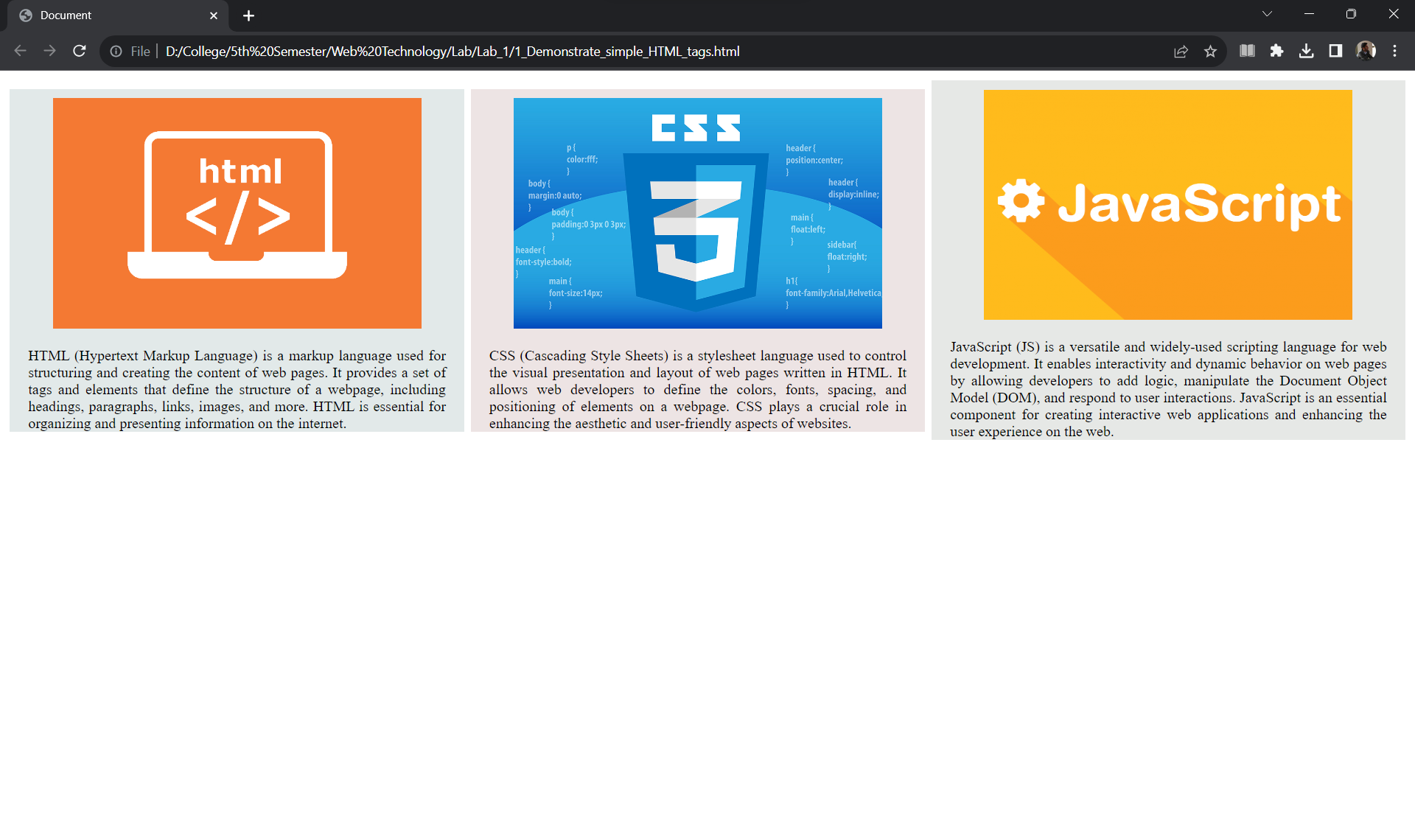

**Task 2:**

**Create a page that shows the course structure of B.Sc.CSIT using list. Also create organizational structure of College of Applied Business**

**Code**

<!DOCTYPE html>

<html lang="en">

<head>

<meta charset="UTF-8">

<meta name="viewport" content="width=device-width, initial-scale=1.0">

<title>Course Structure</title>

</head>

<body>

<h2>Course Structure of CSIT</h2>

<ol class="orderlist">

<li> First Semester </li>

<ul>

<li>Introduction to Information Technology</li>

<li>C Programming</li>

<li>Digital Logic</li>

<li>Mathematics</li>

<li>Physics</li>

</ul>

<li>Second Semester </li>

<ul>

<li>Introduction to Information Technology</li>

<li>C Programming</li>

<li>Digital Logic</li>

<li>Mathematics</li>

<li>Physics</li>

</ul>

<li>Third Semester </li>

<ul>

<li>Introduction to Information Technology</li>

<li>C Programming</li>

<li>Digital Logic</li>

<li>Mathematics</li>

<li>Physics</li>

</ul>

<li>Fourth Semester </li>

<ul>

<li>Introduction to Information Technology</li>

<li>C Programming</li>

<li>Digital Logic</li>

<li>Mathematics</li>

<li>Physics</li>

</ul>

<li>Fifth Semester </li>

<ul>

<li>Introduction to Information Technology</li>

<li>C Programming</li>

<li>Digital Logic</li>

<li>Mathematics</li>

<li>Physics</li>

</ul>

</ol>

<h2>Organizational Structure Of College Of Applied Business</h2>

<div>

<table border="1" style="margin:auto;">

<tr>

<th>College Management Committee</th>

</tr>

</table>

<span style="margin: 50%;">&#8595;</span>

<table border="1" style="margin:auto;">

<tr>

<th>Chairman</th>

</tr>

</table>

<span style="margin: 50%;">&#8595;</span>

<table border="1" style="margin:auto;">

<tr>

<th>Principal</th>

</tr>

</table>

<span style="margin: 50%;">&#8595;</span>

<table border="1" style="margin:auto;">

<tr>

<th>Vice Principal</th>

</tr>

</table>

<span style="margin: 50%;">&#8595;</span>

<table border="1" style="margin:auto;">

<tr>

<th>General Adminstration</th>

<th>Academic Adminstration</th>

</tr>

<tr>

<td>1. Adminstration Section</td>

<td>1. BSc. CSIT Department</td>

</tr>

<tr>

<td>2. Account Section</td>

<td>2. BIM Depatrment</td>

</tr>

<tr>

<td>3. Library Section</td>

<td>3. BBA Depatrment</td>

</tr>

<tr>

<td>4. Exam Section</td>

<td></td>

</tr>

</table>

</div>

</body>

</html>

**Output**

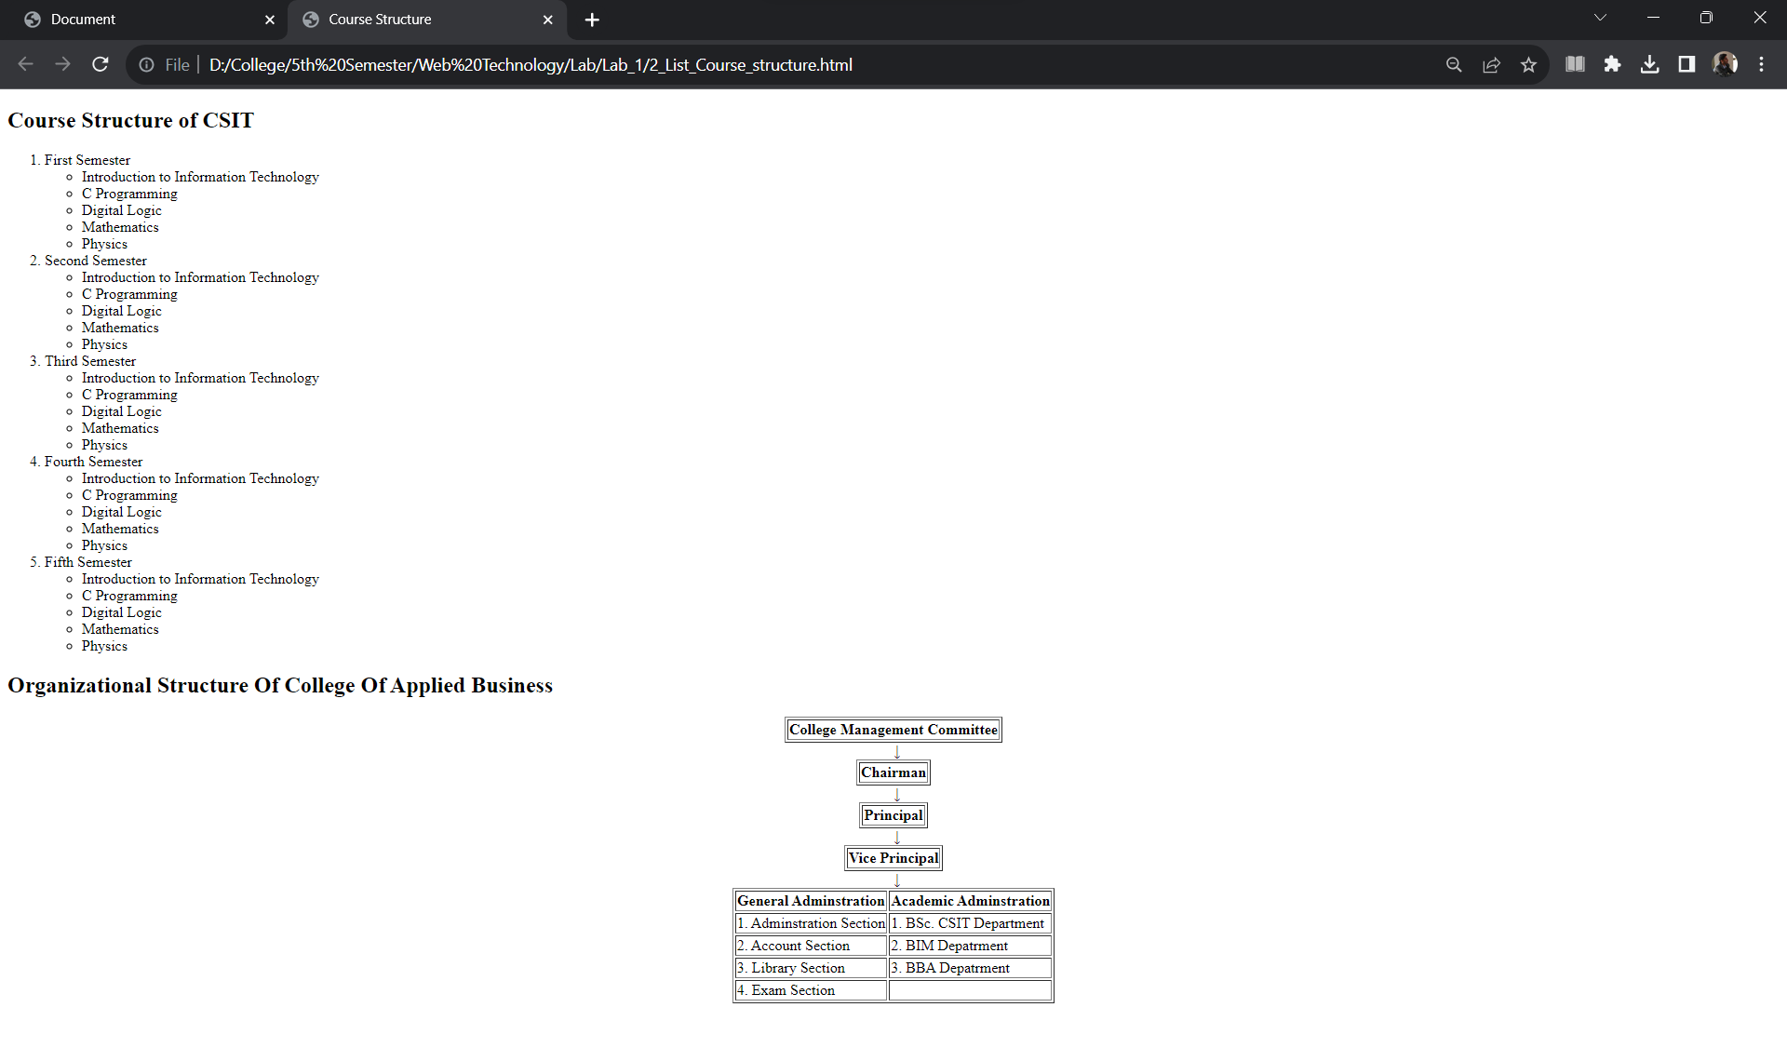

**Task 1:**

**Create a user registration form with necessary fields.**

**Code**

<!DOCTYPE html>

<html lang="en">

<head>

<meta charset="UTF-8">

<meta name="viewport" content="width=device-width, initial-scale=1.0">

<title>User Login</title>

</head>

<body>

<div class="userlogin-form">

<h1>User Regestration form</h1>

<form id="regestration-form" action="">

<div class="input-group">

<label for="username">Username :</label>

<input type="text" id="username" name="username" required>

</div>

<div class="input-group">

<label for="email">Email:</label>

<input type="email" id="email" name="email" required>

</div>

<div class="input-group">

<label for="password">Password:</label>

<input type="password" id="password" name="password" required>

</div>

<button class="submitBtn" type="submit">Register</button>

</form>

<br><br>

<hr>

<div id="tableData">

<h2>Registered Users</h2>

<table id="user-table" border="1px solid black">

<tr>

<th>Username</th>

<th>Email</th>

</tr>

</table>

</div>

</div>

<script>

const regestrationForm=document.getElementById('regestration-form');

const userTable=document.getElementById('user-table');

regestrationForm.onsubmit=(event)=>

{

document.getElementById('tableData').style.display='block';

const newrow = userTable.insertRow(-1)

const username =newrow.insertCell(0);

const email =newrow.insertCell(1);

username.innerHTML=document.getElementById('username').value;

email.innerHTML = document.getElementById('email').value;

return false;

}

</script>

</body>

</html>

**Output**

